Overview of items still left to do for the ecoinvent WWT tool

Compiled by Pascal Lesage based on past emails, discussions and our shared sheet

February 16, 2018

Contents

1 Country mixes 2

1.1 Coverage for primary data 2

1.2 Coverage in practice 2

1.3 Parameters dependent on location – Peter van Rollenghem (data) 2

1.4 Extrapolating – Pascal Lesage (procedure) 2

1.5 Dealing with country mixes – Pascal Lesage (code) 2

2 Technology mixes – general 3

2.1 Description 3

2.2 Final list of technologies – Peter, Yves, George and Lluìs C. 3

2.3 Final list of capacities – done! 3

2.4 Equations for technologies - George 3

2.5 Data for averaging - ??? 3

2.6 Averaging operation – ICRA 4

2.7 Averaging infrastructure - ??? 4

3 GLO default values – All modellers 4

4 Chemical inputs 4

4.1 Chemical inputs (partially in tool) – ICRA, Yves? 4

4.2 Linking to ecoinvent in background 5

5 Untreated fraction – Pascal, Lluìs B. 5

6 Energy demand – Stalled? 5

7 Hydraulic overload – Peter? 5

8 Coarse solids removal – Peter 5

9 Documentation 6

10 Sludge properties 6

11 ecoSpold generation 6

12 Uncertainties 6

# Country mixes

Note: all this was discussed in the past, this is simply a summary.

## Coverage for primary data

**Minimal coverage**: Datasets for WWT must be generated for the following countries: Switzerland, Brazil, Peru, Colombia, India and South Africa

Any additional country data is useful.

## Coverage in practice

The tool will be used for regions other than those listed above. The region of the WW generating activity determines the region of the WWT dataset. Notably, activities that generate WW can be associated with the following regions:

* Global dataset
* Regional dataset (e.g. Europe)
* Country dataset (country part of our list of not)
* Region smaller than a country (e.g. a specific state).

## Parameters dependent on location – **Peter van Rollenghem (data)**

* Mix of technologies (see next point)
* Mean water temperature
* Q (as a function of rainfall, sewer type, Qinfiltration and Qeh)
* BOD load

These parameters **must** be quantified for the “minimal coverage” countries.

They **should** be quantified for any other country for which data is available.

## Extrapolating – Pascal Lesage (procedure)

Data will NOT be available for all countries in the ecoinvent database. We will extrapolate data to other countries. Extrapolation involves three actions:

1. Identification of country from which data is extrapolated;
2. Adjustment of uncertainty data;
3. Modification of certain text fields in the ecoSpold files.

## Dealing with country mixes – Pascal Lesage (code)

Wastewater generating activities (e.g. steel production) in ecoinvent may be associated with regions larger than individual countries (e.g. Europe). The volume of water needs to be split among countries. This will be based on the relative output of the wastewater generating activity in the different countries (e.g. how much steel is produced in each of the European countries). The tool must be able to generate a weighted average of model outputs for these countries.

# Technology mixes – general

## Description

Within one country, wastewater can be treated in WWTP using different technologies and with different capacities. The tool must be able to split the volume of water treated in a given country into the different WWTP types. The tool must be able to generate results on treatment of each of these technologies and create a weighted average.

See email "[ecoinvent WWT project] IMPORTANT: Input from experts required"

## Final list of technologies – Peter, Yves, George and Lluìs C.

The list of technologies was determined early in the project. The tool currently only deals with intensive aerobic treatment.

**The list of technologies really needs to be finalized**.

See email discussion with subject: “ecoinvent-WWT [time sensitive]: need to finalize the technology list”

## Final list of capacities – done!

The final list of capacity archetypes is:

* Class 1: over 100,000 PE (population equivalents)
* Class 2: 50,000 to 100,000 PE
* Class 3: 10,000 to 50,000 PE
* Class 4: 2,000 to 10,000 PE
* Class 5: 30 to 2,000 PE

## Equations for technologies - George

The equations for intensive aerobic treatment have been implemented.

The equations for lagoons have been identified (Metcalf and Eddy (2003), section 8.14).

Equations for anaerobic treatment are missing. George has been identified as the person most likely to supply these equations.

## Data for averaging - ???

The tool will create a weighted average of technologies and capacities based on (**missing**) statistical data on how water is treated in different countries.

For each country, we need to find the % wastewater treated by each (capacity/technology).

**This data is yet to be supplied, and the modeller responsible for finding/estimating this data is yet to be identified.**

## Averaging operation – ICRA

The averaging of operations is done by running the model n times, where n is equal to the number of technology/capacity possibilities in a country, and averaging the result (weighted average based on the point above). This will be done by ICRA, but they first need all the data mentioned above.

## Averaging infrastructure - ???

Infrastructure archetypes still need to be generated.

Ideally, we would want to have infrastructure requirements for all technology/capacity combinations. This is probably impossible, and hence we need to:

* Generate data for some technology/capacity combinations
* Extrapolate to others (based on capacity), and account for uncertainty.

For now, the only data sources found for generating infrastructure data are:

1. ICRA
2. Existing model

THIS POINT IS PENDING AND NEEDS RESOLUTION.

# GLO default values – All modellers

Based on the above and on expert judgement, we need to be able to generate a global default model for countries not included in the tool.

It does not need to be (and indeed cannot be) precise, and uncertainty will be accounted for in the dataset.

# Chemical inputs

## Chemical inputs (partially in tool) – ICRA, Yves?

The chemical input should be calculated by the tool.

Currently, there are two chemical inputs calculated:

* Alkalinity to maintain pH. The chemical used for this is not specified. I need it to be able to link to ecoinvent data.
* FeCl3 for Chemical P removal. This is one of many possible coagulants. The best approach would be to:
  + Calculate the amount of coagulant required for different types of coagulants (see Yves’ table from last fall, [here](https://docs.google.com/spreadsheets/d/1DiBhDCjxGyw2-umImIfHiZOzY5LJF_psGiD4fEf7Wgk/edit?ts=59493cb4#gid=1104649151))
  + Allow the user to select the correct coagulant
  + Default to most common coagulant if user does not choose coagulant (FeCl3?)

Note that the need for flocculants is not calculated.

ICRA: what would you need from modellers?

## Linking to ecoinvent in background

**IRCA** to make a dictionary to pass from tool chemicals (column 1 in the table in the ecoinvent email) to ecoinvent proxy (column 2) and code an automatic comment addition to these inputs in the dataset. If necessary, a correction factor for the amounts should be added.

The email is dated Sept. 13 2017, with subject= “Fwd: RE: WWT Chemicals”

# Untreated fraction – Pascal, Lluìs B.

Not all wastewater generated is actually treated (see [Notebook](https://github.com/ecoinvent/wastewater_treatment_tool/blob/master/Generating%20ecoSPold%20files%20for%20WWT.ipynb) section 5.3).

Required:

1. Formatting of the data on untreated fractions, per country
2. Code for generating an ecoSPold dataset for the untreated fraction (Pascal to specify inputs + outputs, Lluìs to generate javascript code)
3. Subtraction of that fraction from amount treated in each of the n regions (Lluìs)

# Energy demand – Stalled?

The tool does not calculate electricity demand for treatment.

This aspect was extensively discussed in a call in November 2017. The main take-away was that kg O2 (for aeration) should be converted to electricity demand, and that other sources of electricity demand (e.g. pumping, lighting, etc.) should be determined as a function of plant size.

Ivan (one of the editors) supplied an Excel spreadsheet (Nov. 16, 2017) with some regressions allowing the allocation of electricity to different processes within a WWTP.

ICRA: have you acted upon this data since the November call? DO you need the modellers to supply you with more precise guidance?

# Hydraulic overload – Peter?

There are losses in the sewers due to hydraulic overloads (see Section 5.3 in [Notebook](https://github.com/ecoinvent/wastewater_treatment_tool/blob/master/Generating%20ecoSPold%20files%20for%20WWT.ipynb) and email with subject “[ecoinvent WWT project] Untreated fraction, hydraulic overload” dated August 18.

The existing ecoinvent model estimates these as 1% loss for particulates and 2% for dissolved fraction (Swiss). These flushed substances are (1) direct emissions to water in the ecoSPold; and (2) not to be considered in the influent to the WWTP model.

We need to identify regional data for this. It can be correlated to other data Peter is looking for at the moment.

# Coarse solids removal – Peter

In summer 2017, we determined that the coarse solids removed should be better characterized (Peter).

The data in the existing model models 0.31 kg/m3, split 50% plastics, 50% biomass (modelled as paper). Yves says we should add sand.

# Documentation

Documentation of ecoSpold files should be based on Notebook example. More details to come.

# Sludge properties

The sludge generated by the treatment should be characterized, in the ecoSPold file, by its contents in metals, C, N and P. See ecoSpold generation.

# ecoSpold generation

**Status**: Pascal worked on a Python version of the code with ecoinvent in August 2017. Lluis is to transfer everything to javascript.

**Next steps**:

* Lluìs B. will work on a javascript version of the Python script. Pascal will assist as needed.
* Specifically, once Lluìs B. has gotten the first step of the javascript working, Pascal will provide specific expected inputs, outputs and transformations. They are all already explained in the [Notebook](mailto:https://github.com/ecoinvent/wastewater_treatment_tool/blob/master/Generating%20ecoSPold%20files%20for%20WWT.ipynb) and in the [Python script](mailto:https://github.com/ecoinvent/wastewater_treatment_tool/blob/master/waste_water_tool/spold2_writer_functions.py) itself.

# Uncertainties

**Requirement**: The uncertainty of inputs and outputs in ecoinvent must be quantified. Specifically, the following three elements are required:

* **Uncertainty type** (i.e. probability density function). By default, lognormal distributions are used, but we can use other distributions if we prefer, including simple uniform distributions
* **Basic uncertainty**: represents the “baseline” uncertainty, without consideration for the data quality issues covered by the data quality indicators.

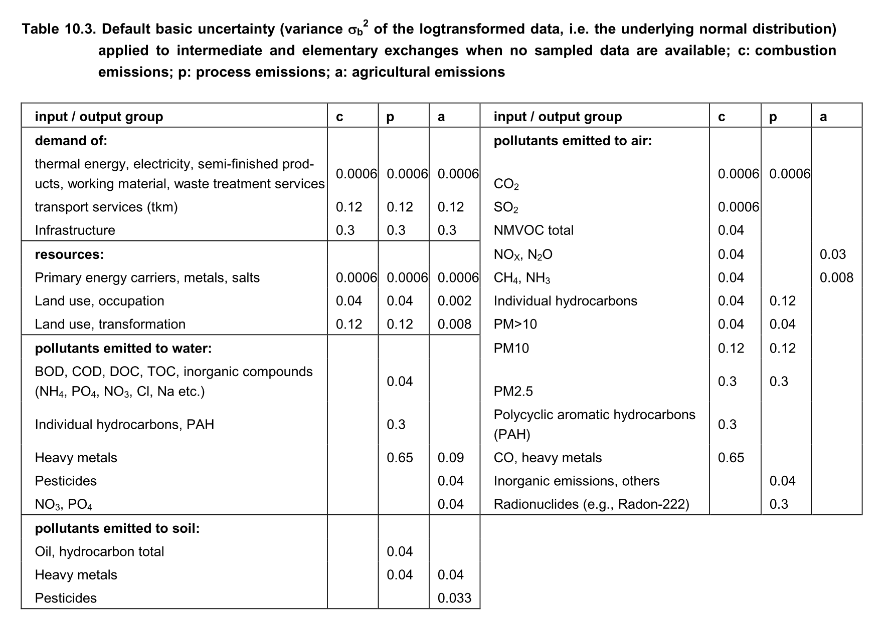

* **Data quality indicators**: based on the Pedigree matrix approach, a score of 1 to 5 are given to each parameter. The following table is used:

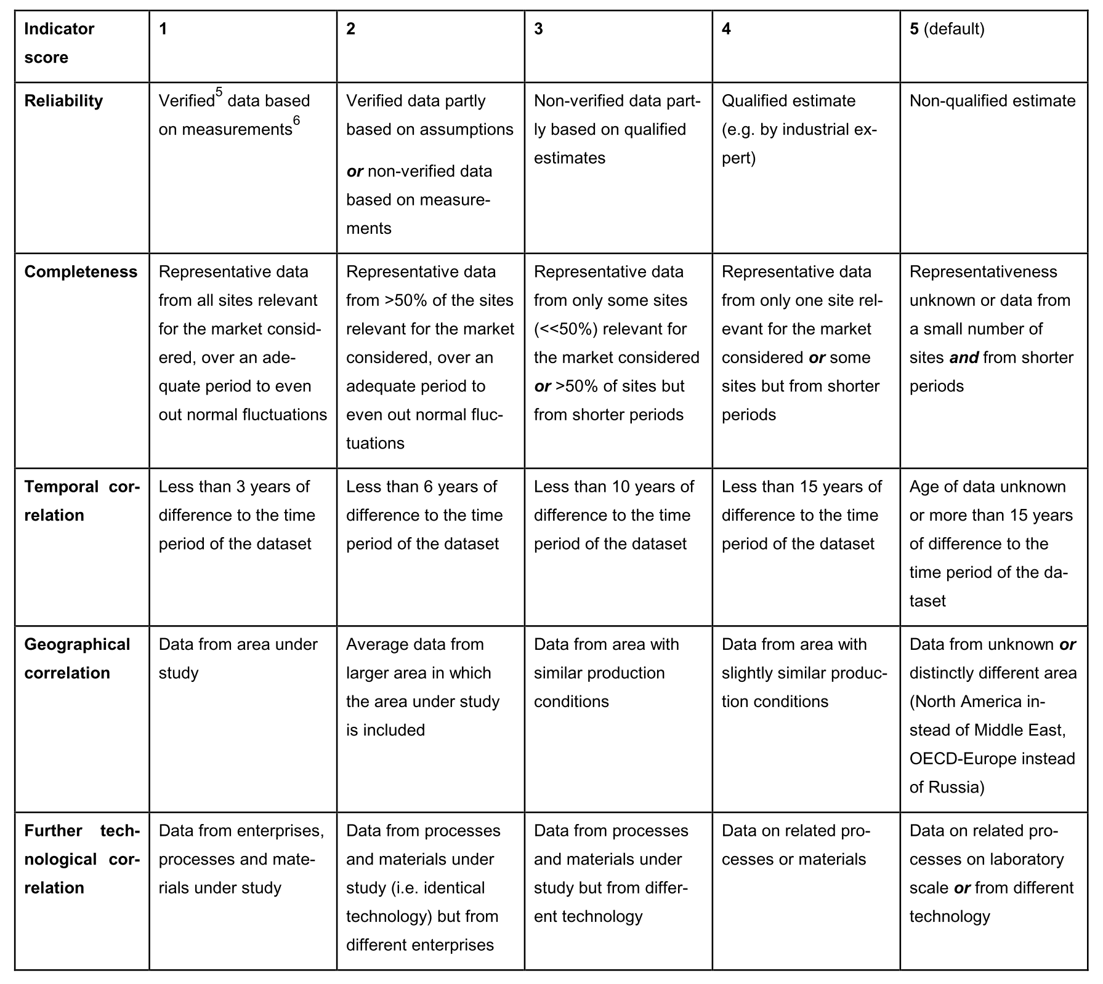

Pascal will be responsible to allocate uncertainty factors to all exchanges. However, this can only be done once the approaches above are finalized.